How to navigate AETS display menu
Vojtěch Míček

Contents
How to navigate in the menu using encoder: 2
INIT: 3
Main Menu: 3
Relays: 4
Set Relay: 4
Relay x: 4
Remain Count: 5
Set Count: 5
Trigger: 5
MOSFETs: 6
Mosfet x: 6
Connectivity: 7
Profile: 7
Settings: 8
INFO: 8
Start Test: 9
Relay Count Low: 9
TEST: 10
Test end screens: 10

How to navigate in the menu using encoder:
Navigation of the menu is done by using encoder. Encoder has an advantage in the fact that it can rotate freely to either direction without stopping. Encoder that is used is equipped with a switch, that can be used by pressing the encoder. This is used to select items.
Where you are in the menu is indicated by the cursor in the first collum from the left.
If you wish to go into the previous menu, select the option < Return on top of each menu.
Cursor:
>

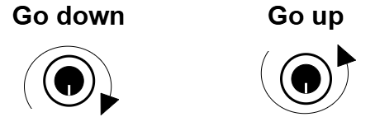

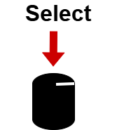

Return:

INIT:
This screen appears on power-up of the device.
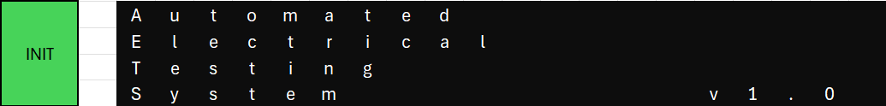

Main Menu:
This is the main screen of the menu. From here you can go to every sub-menu to set up tests, load profiles, set communication etc.
These are the main sub-menus:
- Start test
- Relays
- Mosfets
- Trigger
- Connectivity
- Profiles
- Settings
- Info
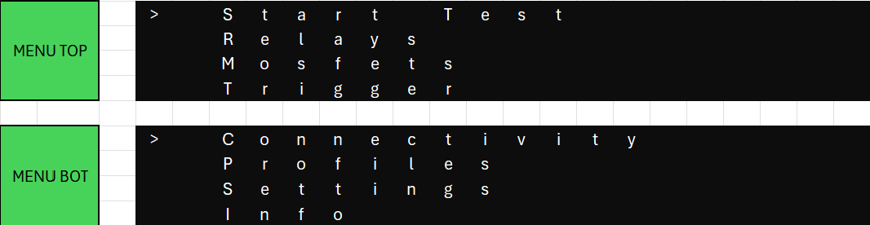

Relays:
Here you can set up to 4 relays.
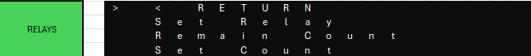

Set Relay:
First you choose which relay you want to configure.
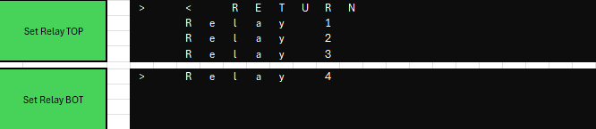

Relay x:
This is the main configuration screen for relays.
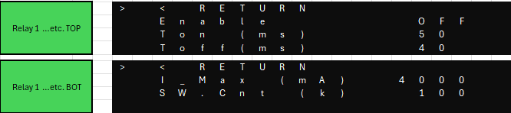
- Enable [ON|OFF]
  - This will enable the relay, and it will be included in the switching sequence
- Ton (ms) [ 0 – 1000000]
  - Time the relay will be on
- Toff (ms) [ 0 – 1000000]
  - Time the relay will be off
- I_max (mA) [0 – 4000]
  - This value sets the maximum current that can pass through the relay. If current is above this value for 3 consecutive times, the test will go into fail.
- SW.Cnt (k) [0 – 1000000]
  - How many times will relay switch on and off. This value is in the thousands!!!

Remain Count:
This screen shows you how many switches each relay has remaining. This is read-only information
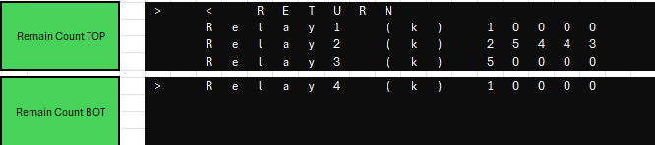

Set Count:
This screen is used to setup switches for new relays.
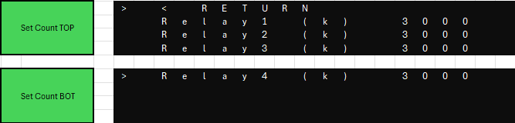

Trigger:
Trigger menu allows you to activate trigger output. You can choose with which relay it will activate. Trigger is activated when relay turns on
- Enable (ON|OFF) – Enables trigger in the testing
- Relay Ch. – Choose which relay channel will the trigger follow

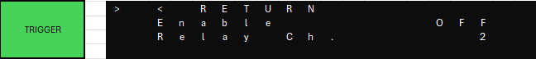

MOSFETs:
Here you can choose which channel you want to configure.
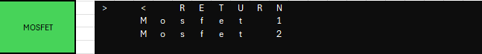

Mosfet x:
This is the main configuration screen for mosfets.
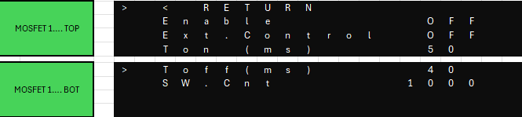
- Enable [ON|OFF]
  - This will enable the mosfet, and it will be included in the switching sequence
- Ext.Control [ON|OFF]
  - This changes driving of the MOSFET from MCU control to external control. External control is utilized by BNC connector. This allows you to connect waveform generator to the device and bypass MCU control. Be aware to connect BNC cable to the right channel you want to use.
- Ton (ms) [ 0 – 1000000]
  - Time the mosfet will be on
- Toff (ms) [ 0 – 1000000]
  - Time the mosfet will be off
- SW.Cnt [0 – 1000000]
  - How many times will mosfet switch on and off.

Connectivity:
In this menu you can configure communication options.
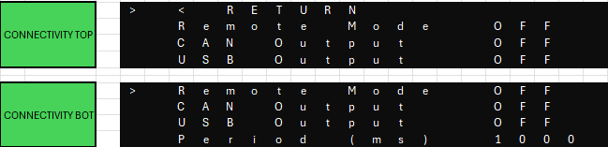
- Remote Mode [ON|OFF]
  - This allows you to switch to remote mode, where you can control the device via commands using Virtual Serial Port.
- CAN output [ON|OFF]
  - If switched on it will output data in 2 frames during the test from DSUB-9 connector
- USB Output [ON|OFF]
  - If switched on it will output data into Serial Port during the test from USB-C connector
- Period (ms) [200 - 100000]
  - Determines period of sending output data during test.

Profile:
Here you can save your test settings or load them up. The device has 6 profiles available.
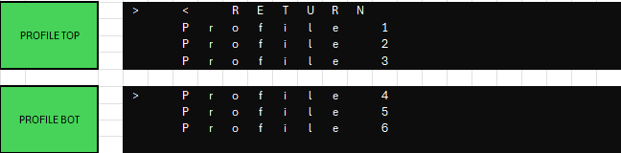

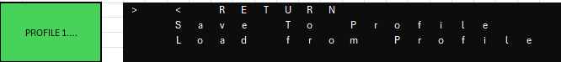

Settings:
Here are basic system settings.
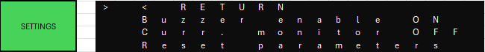
- Buzzer enable [ON|OFF]
  - Turn on/off sound feedback of the device.
- Curr. monitor [ON|OFF]
  - You can turn monitoring on/off for the test. This is used for internal control of relay -> overcurrent / zero current faults
- Reset parameters
  - This refreshes all system values to default state.

INFO:
This menu displays information about the device.
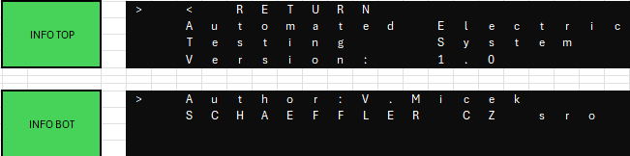

Start Test:
Here you can choose which configuration of test you want.
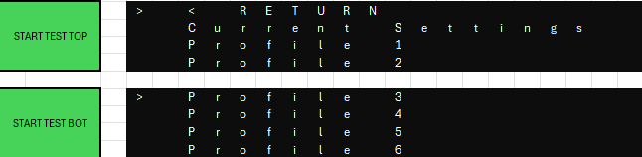
- Current Settings
  - Starts test with configured values.
- Profile 1-6
  - Starts test with configuration values loaded from the selected profile.

Relay Count Low:
If you want to start test where you have configured switches on relay that are larger than the remaining count of the relay, this screen will appear notifying you which relay needs to be reconfigured.
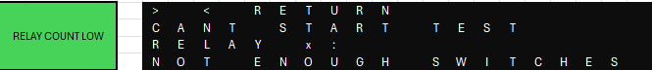

TEST:
Screen during test. You can stop test manually by pressing the encoder or by stopping test remotely.
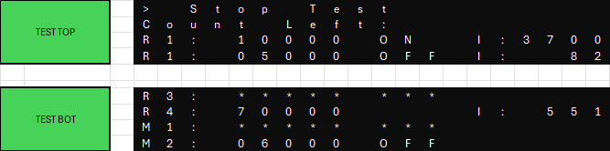
- Enabled peripheries:
  - Relays:
    - Shows remaining count, state of the relay, current in mA
  - MOSFETs:
    - Show remaining count, state of the MOSFET
- Disabled peripheries:
  - If the periphery isn’t used, it will fill the row with *****

Test end screens:
